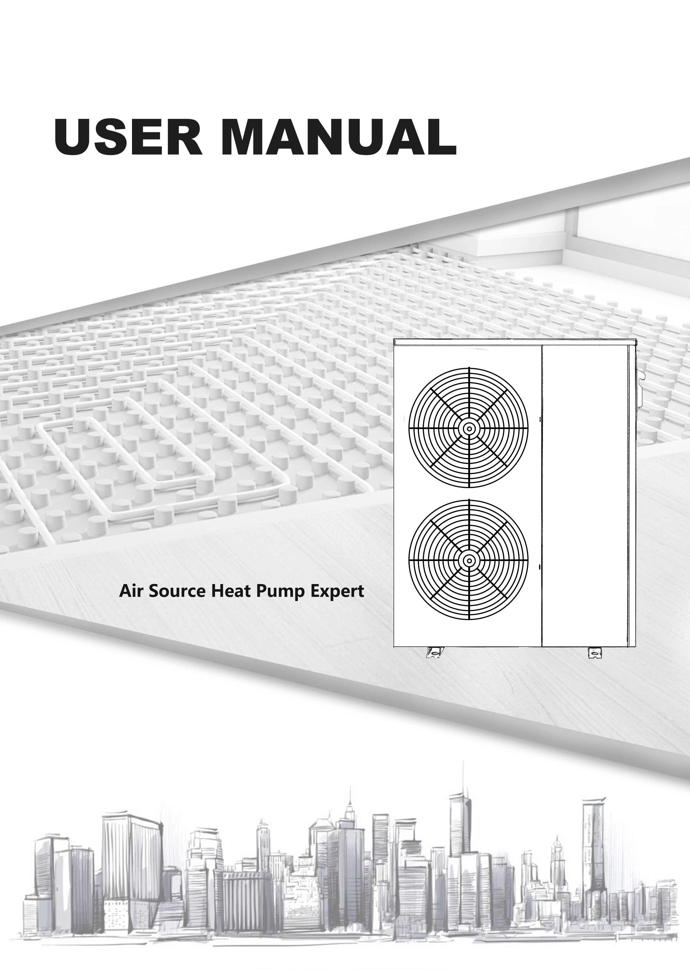

CONTENT

I. Prologue 2

II. Main instruction of product 4

III. Installation ...........................................7

IV. Trial running 15

V. Operation panel instruction 16

VI. Maintenance & Repair 34

SiteUrl: www.honmingchiller.com

Please Read the Manual Carefully before Operation

Please read this manual carefully before installation

- The heat pump unit must be installed by the professional technician.

- Please install the heat pump and connect the water pipes in accordance with this manual strictly.

- For safety consideration, please make sure to re-check that everything before the power on.

- If the machine with any improvement, the content is subject to change without notification.
- Prologue
Thanks for choosing HON MING heat pump for your heating cooling or sanitary hot water solutions!
Please read this manual carefully before installation and operation! This manual contains the information about installation, electrical debugging, operation, and maintenance. The following items should be focused:
1. Before installation, please confirm if your local voltage supplying matches with the voltage which showed on the machine's nameplate and if the carrying capacity of the power supply, wires and plug bases are suitable for the range of this machine's input power.
2. Users are not allowed to change the power line or plug base by themselves. All wiring works must be carried out by a qualified electrician, please 100% be sure to connect the earth line correctly. If the earth wiring is not connected correctly, it may cause electric shock accidents.
3. After the completion of the construction of all wiring work, please make sure to recheck that everything is well connected before power on.
4. Installing the machine in the place which the combustible gas may leak is strictly forbidden.
5. Do not put your hands or foreign matters into the air outlet of heat pump unit, otherwise it will be dangerous to the people and equipment nearby.
6. In order to obtain a better energy-saving effection, the unit should be installed in a place with well-ventilated.

ATTENTIONS:
1. Please make sure the water circulation system filled with enough water before the machine starts working.

2. When the machine is under operating, all valves of the water systems must be in the open positions.
3. If without inlet water or with a long time stopped using, when re-boot the machine, please refer to the item of attentions 1.
4. A removable filter must be installed at the water inlet and please clean the valve periodically depend on your locate water quality (every 2 or 3 months).
5. The maximum water temperature is 55℃, at hot water heating mode, please adjust the water
temperature to a appropriate temperature (The most comfortable water temperature for shower is 38C~42C , if the water temperature above 50℃ , there might be with danger of burning skin!)
6. The maintenance of the machine must be carried out by professional electricians.

7. When the unit get powered off, please discharge all the water inside the water circulation system. Otherwise the heat exchanger might be frozen at cold ambient temperatures.

8. Please confirm the installation location of the main controller. When installing the main controller, be sure to install it in a waterproof place, and the installation must be firm.

9. Please install with leakage protection switch. Check whether a leakage protection switch of suitable power is installed between the unit and the power supply, if the leakage protection switch is not installed, it may cause electric shock or fire.
- Check the water flow and pressure of the circulating water of the equipment when the equipment is at normal use, it must be ensured to prevent the unit from being protected and running short of water.
- Do not move the detector freely. The temperature detector must not be separated from the water tank temperature detection blind pipe to avoid overheating of the unit heater and might cause the unit damaged.
- The unit’s maintenance and repairing by non-professional technicians to repair or adjust the advanced factory controlling setting of the unit by themselves are not allowed, please contact the local service providers or distributors for the operation.
- The fuse selection must match with the unit. It is forbidden to use corresponding fuse which is not suitable. Otherwise it may cause system errors or cause a fire.
- Prevent the unit from fire. Do not spray flammable spray directly to the unit, otherwise it may cause a fire accident.
- Please cut off the manual power switch immediately when an abnormality (with burnt smell) occurs, stop any further operation, and contact the local service providers or distributors.

If the abnormal operation continues, it may cause electric shock or fire.
- Emergency measures after out of water or electricity supplying,

In cold areas, please do not cut off the water and power supply to avoid freezing the heat exchanger and the water circulation system. In the event of a power failure, please drain all the cold water out of the heat exchanger and the whole water circulation system, otherwise the heat exchanger will be damaged by freezing and the unit cannot be used normally.

It is recommended with a condensed water drain pipe installed during engineering installation to prevent a large amount of condensate water from flowing to the ground during drainage and causing large areas of water to accumulate.
II. Main instruction of product
- Parameter
Model | Size(L*W*H mm) | Net Weight(KG) | Power Supply
HMAW-03ZR1-V | 996x470x1000 | 100 | 220V～Inverter~1N
HMAW-04ZR3-V | 996x470x1000 | 125 | 380V～Inverter~3N
HMAW-05ZR1-V | 996×470×1385 | 150 | 220V～Inverter~1N
HMAW-05ZR3-V | 996×470×1385 | 155 | 380V～Inverter~3N
HMAW-08ZR3-V | 1196×568×1386 | 175 | 380V～Inverter~3N

- Appearance
HMAW-03ZR1-V/HMAW-04ZR3-V
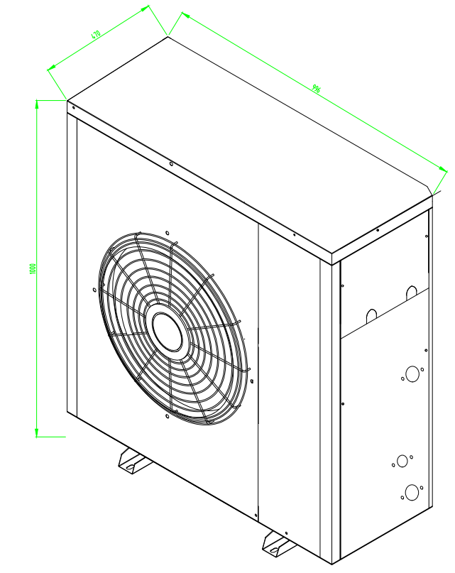
HMAW-05ZR1-V/HMAW-05ZR3-V

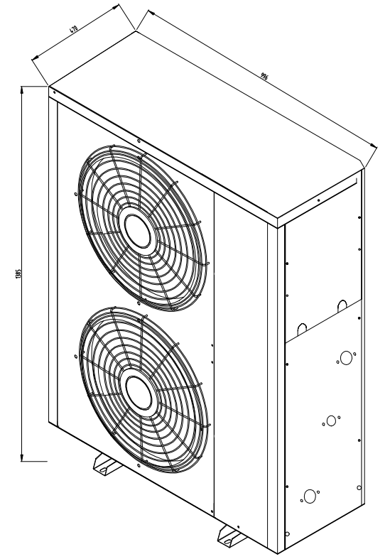

HMAW-08ZR3-V

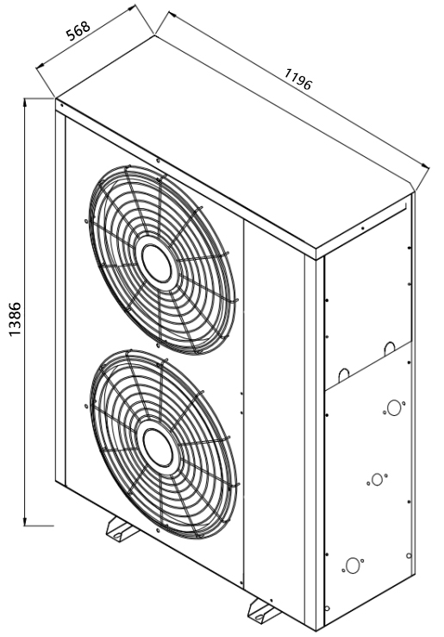

III. Installation

1.Heat pump installation
(1) Installation location
◆The heat pump must be installed exclusively outside the home and, where possible, in a completely clear area. If a protection is needed around the appliance, it should have wide openings on the 4 sides and the installation separations indicated in the following figure must be respected. No obstacle should prevent the circulation of air through the evaporator and the fan outlet.
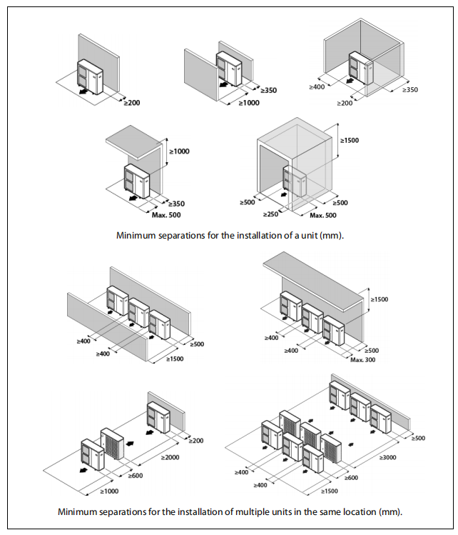

◆Consult with the user before choosing the location of the device. It should not be placed next to sensitive walls,such as on the wall next to a bedroom. Make sure that the location of the heat pump is not disruptive to neighbor (sound level, air currents generated, low temperature of the air blown with risk of freezing plants in the path, etc.).
◆Choose a location that preferably has sunlight and is protected from strong and cold winds. If the heat pump is exposed to gusts of wind that make it possible to overturn it, it should be supported by suitable guys,as indicated in the figure.
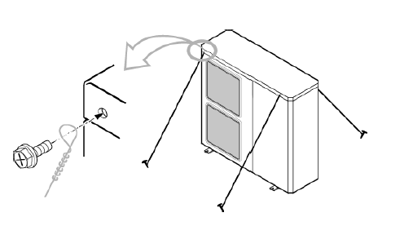
◆The device must be sufficiently accessible for subsequent installation and maintenance work. Make sure that the passage of the hydraulic and electrical connections to the interior of the house is possible and comfortable. The spacing measures indicated in the figure above are those strictly necessary to ensure correct operation of the device; however, sometimes, it will be essential to provide more space for maintenance work.

◆The heat pump is a device specially designed for outdoor installation. Nevertheless, avoid installing it in a place where it may be exposed to significant water stains or spills (e.g. under a faulty gutter, near gas outlets,etc.) . Move the appliance away from heat sources and flammable products.

◆In areas where abundant and copious snowfalls occur, special care must be taken to protect the heat pump from possible obstructions due to accumulation of snow around it. The obstruction of the air inlet and/or outlet of the machine due to the accumulation of snow may cause malfunction of the unit and possible breakdowns. The heat pump must be raised at least 100 millimeters above the maximum expected snow level. In turn, the roof should be protected from accumulation of snow, by means of a roof projecting from the building or a similar structure.

2.Hydraulic installation
◆The hydraulic installation must be made by qualified personel.
2.1 Selection circulation pipeliDetermine the diameter of the water pipe according to the rated water flow of the machine. As shown in the table below：ne：The water flow velocity inside the water pipe is generally required to be 0.8~1.5m/s. The maximum water flow velocity cannot exceed 2m/s.

Water flow（m³/h） | ≤1 | 1~2 | 2~3 | 3~4 | 4~5
Recommended pipe diameter(mm)（flow velocity 1.2m/s ） | DN20 | DN25 | DN32 | DN40 | DN40
Minimum pipe diameter(mm)（flow velocity 1.8m/s ） | DN15 | DN20 | DN25 | DN32 | DN32
2.2 Calculation of water pipe resistance：Hmax=P1+P2

◆ Water pressure drop inside the machine. Can be found on the machine’s nameplate.
◆ Water pressure drop in piping system. If the water flow velocity is 1.2m/s, the resistance of the straight pipe is 0.6 Pa/m, and the resistance of each elbow is 2Pa.If the water flow velocity is 1.8m/s, the resistance of the straight pipe is 1.25 Pa/m, and the resistance of each elbow is 4.5Pa.

2.3 Pump selection
◆According to the rated flow of the machine and the calculated water pressure drop.To decide if you need to install an additional circulating water pump.

2.4 Installation of floor heating

◆The water flow speed in the fool heating pipe is not less than 0.25m/s, and the general design
is 0.25~0.5m/s.

◆The distance between the pipes is 150~200mm;

◆The length of each loop does not exceed 80m,and the general designed is about 40~70m.
The length difference between different loops does not exceed 10m.

3.Installing a DHW tank

◆The heat pump may include (optionally) in its installation a tank for the production of domestic
hot water. The hydraulic installation of the tank must be made by qualified personnel, subject
to the applicable installation legislation and attached instructions of the tank.

◆To combine an DHW tank with the heat pump, insert the DHW tank sensor supplied with it into the tank sensor housing. In addition, a 3-way diverter valve (G1) must be installed between the external machine and the DHW + heating/cooling installation, by means of what, the electronic controller diverts the water from the heat pump to the DHW production or to the heating/cooling installation, depending on whether there is demand for DHW.

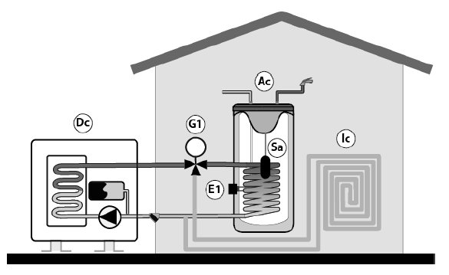
◆In addition,optionally,a backup heater (E1) can be installed, by means of what DHW
temperatures higher than 50℃ can be obtained.

As alternative to the backup heater, the heat pump optionally allows the connection of a conventional source of energy (as a gas boiler, oil boiler, etc.) as back up for DHW production, by means of the same electrical connection E1. For it, the DHW tank must be provided with an auxiliary coil exchanger and/or any intermediate system of exchange that allows the hydraulic connection of the above mentioned backup source of energy.

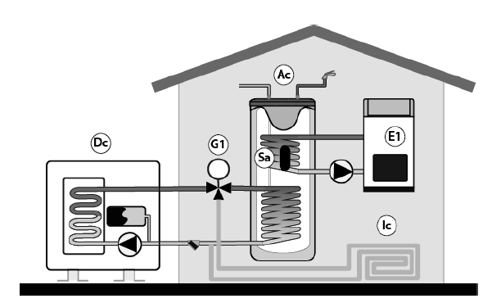

To perform the electrical installation of the DHW tank sensor, the 3-way valve (G1), and the backup heater or boiler(E1), read the “Electrical Connections” section of this manual carefully.

4.Main components and working principle of water circulation system
4.1 pump: push the water circulate in the water circulation system to realize the heat exchange between the heat pump and the water terminus.

4.2 Filter: Collect impurities in the water system to prevent impurities from entering the heat pump and the water terminus’s heat exchanger to cause blockage.

4.3 Buffer tank: Increase the amount of water in the system,reduce the change rate of water temperature, improve comfort; balance the different temperature difference and flow demand between the heat pump and the water terminus.

4.4 Safety valve: keep the pressure of the water system not exceeding the maximum limit.

4.5 Expansion vessel: balance the pressure of the water system when the volume of water changes.

4.6 vent: remove the air in the water system and ensure that the water cycle is normal.

5.Estimate the heat demand for room heating

Q=K*qn*S
Q Total heat demand for housing
K Additional factor
qn Heat demand per square metre
S Heating area

5.1 qn experience values for different houses
Apartment（W/m²） |  | Single house（W/m²）
Living room | 100~130 | Living room | 120~150
Bedroom | 110~140 | Bedroom | 120~150
Study room | 100~120 | Study room | 110~130

5.2 Additional factor
Ratio of heating area to total room area | >0.55 | 0.4~0.55 | 0.25~0.4 | <0.25
Additional factor K | 1.0 | 1.25 | 1.35 | 1.5
The rated heating capacity of the heat pump must be ≥Q.

6.Calculation and selection of buffer tank

6.1 Minimum water volume in the water system
Considering the comfort of heating, it is best not to reduce the temperature of the water supply by more than 5℃ during the defrosting in winter. The general defrosting time is about 4 minutes.
Mmin=Q*T*2*1000/(60*5*1.163）
Mmin Minimum water volume in the water system（L）
Q The rated heating capacity of the heat pump(KW)
T The defrosting time（minute）
M2 Total volume of other parts in the system except the buffer tank

6.2 The volume of the buffer tank must be ≥Mmin-M2

6.3 If M2>Mmin,It is not necessary to install a buffer tank。

6.4 For the correct operation of the heat pump, a minimum water volume must be ensured
in the installation, as well as a minimum flow in the hydraulic circuit of the machine.
If the minimum circulation flow is not reached by the heat pump, it will be blocked, and an alarm code will be displayed on the controller display. According to the different capacity model installed, these volume will be as below,

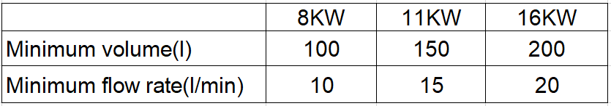

6.5 If the water volume of the installation is lower than this value, install a buffer tank in the
heating/cooling circuit. To avoid condensation and premature deterioration of the buffer tank, make sure that all hydraulic fittings and connections are properly insulated, especially when the tank is to be used in Cooling mode.

6.6 In multi-zone installations managed by thermostatic or similar valves, some method must be provided to maintain the minimum flow rates indicated above, even when all zones are closed (bypass valve, etc.).

7.Connection diagram
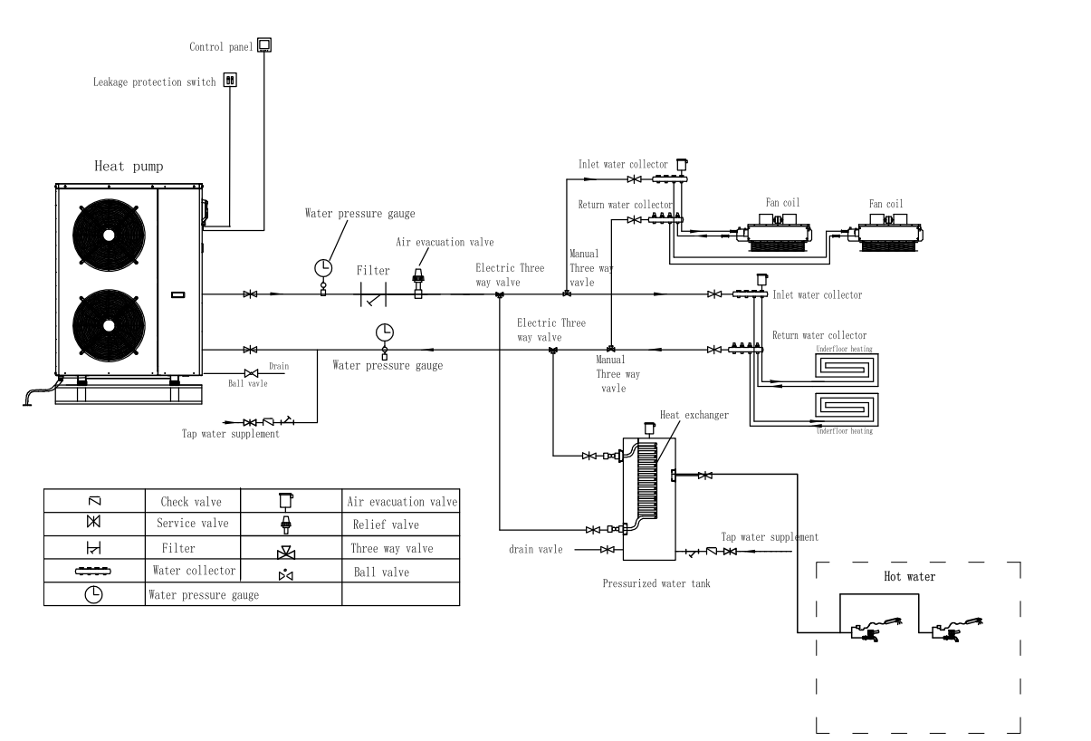
8.Circuit connection
- Attentions
◆Construction wiring must be installed by a professional technician for construction in accordance with the circuit diagram.
◆Appliance installation wiring should be installed in accordance with national wiring rules.
◆Before installation, please confirm whether your local voltage is match with the voltage showed on the machine’s nameplate and whether the carrying capacity of the power supply, wires and sockets are suitable for this machine’s input power.
◆The power source wire diameter is selected by the nameplate maximum current.
◆The regulation of insurance tube: according to the reality.
◆Users are not allowed to change the power cord, wiring work must be carried out by qualified electricians, and to ensure that the machine metal parts has a good connection with grounding, the machine shall not be allowed to change the grounding method. The electrical connection of the heat pump must be protected by an earth leakage circuit breaker (a high-speed switch of 30 mA (<0.1s)).

◆The power connection must be equipped with the unit matching and at least 3mm contact with the power from the all-pole disconnect device and leakage protection device.
◆If the power soft wire is damaged, it must be replaced by the manufacturer, its service department, or similar professional to avoid danger.
◆Do not insert hands or foreign objects into the outlet of the unit, which will lead to the danger of personnel and equipment.
◆The remote controller is fixed by screw and installed indoor with the height above 1.5M. It is forbidden to install in the environment where the humidity, rain, acidity, corrosivity and light illuminate directly.
◆The water quality of the unit must meet the national standard of domestic water consumption, otherwise it will cause the machine damage, the company does not bear any responsibility.

IMPOTTANT: Before carrying out any work on the electrical installation of the heat pump, always ensure it is disconnected from the mains.

IV. Trial running
- Trial running must after all the installation completed.

2.Please confirm the following matters before the trial operation, put “√”in the boxes after confirmation

▲ Unit is installed correctly

▲ Power supply meets unit’s rated power source need

▲ Piping and wiring are correctly installed

▲ Unit air inlet/outlet well-ventilated

▲ Drain off water is done well

▲ Leakage protective device act effectively

▲ Pipe thermal insulation

▲ Grounding wire connected correctly

- After check and ensure correct, then power on. If the control panel display nothing, that should recheck and tight the line of control panel. The control panel should display time, setting temperature and the current temperature.

- Discharge the air out of the pipelines and then press ON/OFF button, the unit work under the setting temperature, unit’s trial running would check the following:

▲ First time to run the device, check the current normal or not;
▲ The function keys on operation panel are normal or not;
▲ The indicator light is normal or not;
▲ The whole circulating hot water system has water leakage or not;
▲ The condensed water discharge is normal or not;
▲ System’s pressure is normal or not (according to the high water temperature or low
pressure);
▲ Whether there is abnormal sound and vibration during operation;
▲ The wind, sound and condensate of the unit affect the neighborhood or not;
▲ Whether there is leakage of refrigerant.

V. Operation panel instruction

H&T Remote control (with hot water function)
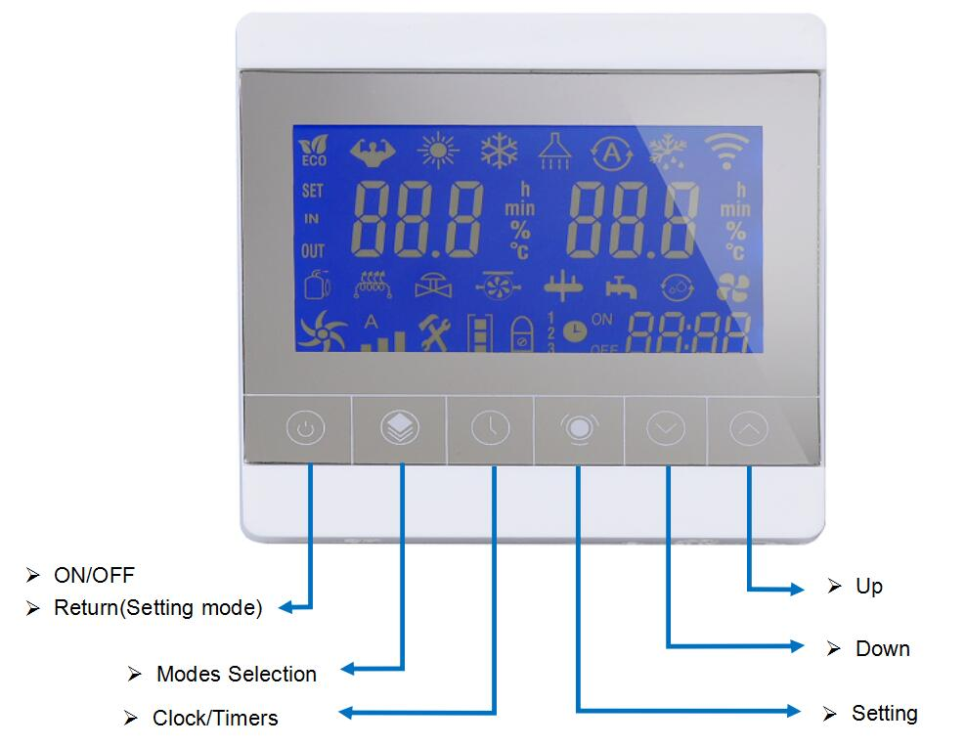

Icon List
1 |  | Energy Conservation Mode | 11 | 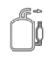 | Heat Pump Compressor
2 | 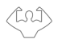 | Powerful Working Mode | 12 | 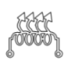 | Electric Heater
3 |  | Heating Mode | 13 | 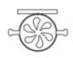 | Water Pump
4 |  | Heating Mode | 14 |  | 4-Way valve
5 | 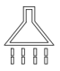 | Water-Heating Mode | 15 |  | Heat Pump FAN
6 |  | Automatic Mode | 16 | 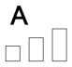 | Wind speed steps of FAN
7 |  | Defrosting Mode | 17 | 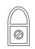 | Lock
8 |  | WIFI connection status | 18 |  | Multi-phase Timer
9 |  | Setting | 19 |  | Timer ON/OFF
10 |  | Water Inlet | 20 | 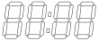 | Time

1.Power On/Off and Lock Function


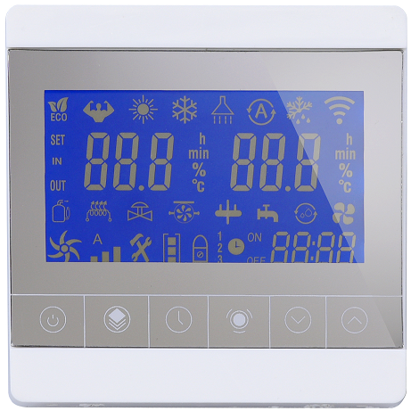
Lock Icon
On/Off Button

1.1 Icon Definition
- 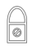 Lock Icon-- the symbol lights up to indicate that the display is locked

1.2 ON/OFF Operation Steps
Step One: Lightly press this button to switch from power on/off;
Step two: In the main interface, tap this key to shut down directly; in other settings interface, tap this key to return to the main interface;

1.3 Unlock Operation Steps
Step 1(Lock):Press and hold the switch button for 5s (or do not operate the wired controller for 60 seconds) to lock the wired controller (to prevent children from playing randomly at home). In the locked state, pressing other buttons is invalid. Lock light, the icon lights up to indicate that it is locked.
Step 2 (Unlocking): In the locked status, long press this key for 5s to change from the locked state to the unlocked state, and pressing other keys is valid at this time.

2．Mode Selection
Mode Selection

Mode Selection

2.1 Icon definition
    - Heating Mode
In this mode, the heat pump continuously heats the water temperature to the set temperature point.
    - Cooling plus hot water(Could be used for triple combination supplying)
    -  Heating plus hot water(Could be used for triple combination supplying)
    - Cooling Mode
In this mode, the heat pump uses cooling to lower the water temperature to the set temperature point.
    - Defrosting Mode
The system's automatic or manual defrost mode allows the heat pump to maintain high system efficiency and save energy
    - Hot water mode
This mode is only limited to triple function heat pump models for domestic hot water heating
    - WiFi connection function

2.2 Operation Steps
Step 1: Confirm Whether the LCD Screen is unlocked or not，（“”means locked）；
Step 2：In the locked status, pressing and holding the button for 5s can change from the locked status to the unlocked state, and pressing other keys is valid at this time;
Step 3: Press and hold the button for 5 seconds to select different modes, in sequence "heating mode" "cooling mode" "hot water mode" "cooling + hot water mode" heating + hot water mode
The mode selection is selected according to each model, refer to Chapter 6)
Note: (The display working mode of the wired controller is limited by the model selection (S02). If the single-cooling model is selected, the wired controller will automatically switch to the cooling status, and the heating and automatic modes cannot be switched. If the single-heating model is selected After that, the wired controller automatically switches to the heating status, and the cooling and hot water cannot be switched.)

Step 2
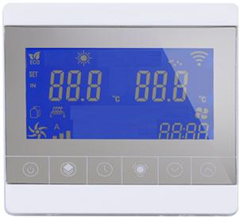

Step 1
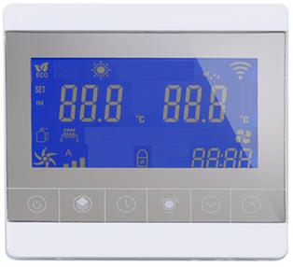

5S

Check lock status

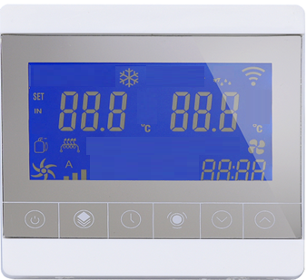
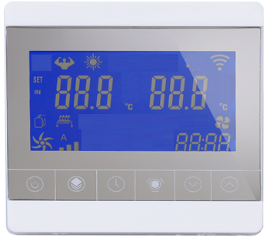

mode selection

mode selection

Function 1: In the heating operation, in the unlocked state, press and hold thekey + key for 5S to enter the manual defrosting mode;

5S

Check lock status

Function 1

5S

Heat Mode selection

3．Key Parts Working Display
Key Parts

3.1 Icon Definitions
    - Heat Pump Compressor
    - Electric Heater
    - Water Pump(For some models: light on means the water pump is working; flashing on means water flow failure; The original water flow failure reporting E03 code function was replaced by the functions bellow)
    - 4-Way valve
    -  Water way three-way valve
    - Water Inlet Temperature
    - Heat Pump Fan

4. Timer Setting

Real-time water inlet temp

Real-time water outlet temp

Clock/Timers button

Timer Setting

4.1 Icon Definitions
    - :multi-phase timer setting
    -  Timer ON/OFF
    - 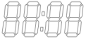：Time
    - 4.2 Time setting operation steps：
    - Step 1:In the main interface, press the "" .It means enter to the Time Setting,the time icon””will display.When the "hour" digit is flashing,please press “”or“”key to set the “hour”.
    - Step2 : After finishing setting the "hour" digit, press "" once, it means that the setting of "hour" digit has been confirmed.
    - Step 3: At the same time, the position of "minute" will flashing,that means it has entered the setting state of the "minute" . Please press the "" or "" key to set the "minute"digit.
    - Step 4: After finishing setting the "minute" digit, press "" once, it means that the setting of "minute" digit has been confirmed; Till then the time setting operation has been completed and the setting interface has been exited.

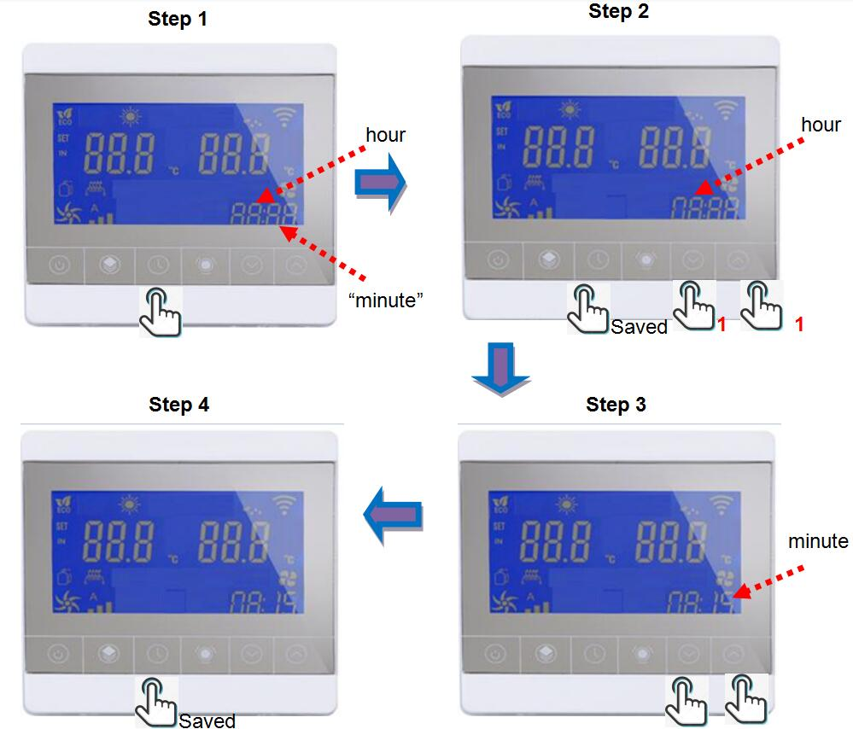

4.3 Timer Operation Steps
    - Step 1: Set the first group of timing on/off settings, press and hold the "" button for more than 5 seconds, when you see When the “ ” is bright, it means entering the first group of timing power-on setting operations;press and hold the "" button for more than 5 seconds, you will see“ ”is flashing . it means entering the first group of timing power-on setting operations;
    - Step 2 :press the "" or "" key to set the "hour" digit and then press "" once to confirm the "hour" digit you set.
    - Step 3:At this time, it enters the "minute" digit setting state of the time, you will see the "minute"position is flashing. At this time, press the "" or "" button to set the "minute" digit, then press “” once to automatically enter the timer shutdown setting operation;
    - Step 4: Enter the timer shutdown setting operation, you will see “ ”display bright. Please press the “” or “” key to set the “hour” digit and then press “” once to confirm the setting. At the same time it has entered the "minute" digit setting state, you will see the "minute" position is flashing, press the "" or "" key to set the "minute". After setting the first group of time, press the "" key to confirm and return to the main interface.
    - For example:Set the timing on at 8:15, the machine will automatically turn on at 8:15 every day.The same operation for the timing off
Step 2
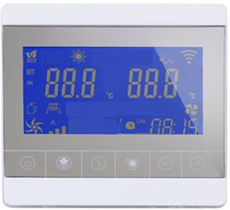
Step 1

hour

Saved

5S
1
1ST phase ON timer light
Step 4
Step 3

minute

Saved ON timer data and
enter OFF timer setting

1
Saved 1st phase ON/OFF timer data

1

4.4 Multi-phase Timer Operation Steps
The setting of the second and third groups of timing on/off: after finishing the setting of the first group of timer, do not press the "" key, but then press the "" key once to enter the second group of time setting, At this time, you will see“”, do the same operation as the setting method of setting the first group of timer on/off (refer to chapter 4.3) to set the second and third groups of timer.
Step 4 from chapter 4.3

Saved 1st phase ON/OFF timer data

change

4.5 Cancel Timer Function
After starting the timing function,press and hold the “”key more than 3S to cancel the timing function.

5.Browse Function
Function 1: Press "" or "" key to turn pages to browse related parameters;
Function 2: In the main interface of the power-on state, press the "" or "" key to set the set temperature value in the current mode; after the setting is completed, press the "" key to confirm and return to the main interface

Function 1
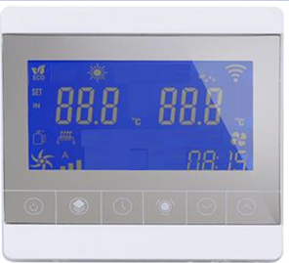

Display parameter codes

Display parameter value



Function 2

Current mode

Current Temperature

1
1
Saved

6.Parameter setting function
WARNING: The "" setting key is an important parameter used to set the machine's operation. It is specially provided for professional after-sales maintenance personnel. Please set it carefully for home users, otherwise there will be a risk of loss of the machine.
Step 1: Short press the setting button "" once to enter the system P parameter setting (the switch state can be set);
Step 2: Press the "" or "" key to turn the page to query the parameters, and then press the setting key "" to select the parameter value;
Step 3: Combine the "" or "" keys to modify the parameter value
Step 4: Then press the setting key "" to confirm, press the on/off key to return to the main interface; if there is no operation for 60s in the parameter setting interface, it will automatically exit and return to the main interface.
Function 1: Press and hold the setting button "" for 3S to enter the S parameter setting, (repeat steps 1~4)
Function 2: Press and hold two keys at the same time for 5S (i.e. power-on key "" + setting key "" ) to enter F parameter setting, (repeat steps 1~4)
Note: The display working mode of the wired controller is limited by the model selection (S02). If the single-cooling model is selected, the wired controller will automatically switch to the cooling state, and the heating and automatic modes cannot be switched. If the single-heating model is selected , the wire controller automatically switches to the energy-saving heating state, and the cooling and automatic modes cannot be switched.
Function

Display parameter codes

Display parameter value

3S

Function 2

5S
5S
At the same time

7.ON/OFF Device working indicator light
The indicator light is green: the device is on or in standby；
The indicator light is blue: the device is in normal operation；
The indicator light is red: device failure；
When the remote control is unlocked, long press the clock button+up key“ 5S,the light panel display function can be turned on or off

8.Parameter List

8.1 Parameter status query（Parameter Browse，pressMode key to enter）
Code | Description | Settable range | Unit
c01 | Ambient temperature |  | 0.1℃
c02 | Outer coil temperature |  | 0.1℃
c03 | Exhaust gas temperature |  | 0.1℃
c04 | Suction temperature |  | 0.1℃
c05 | Indoor temperature |  | 0.1℃
c06 | Outdoor temperature |  | 0.1℃
c07 | Inner coil temperature temperature(after throttling) |  | 0.1℃
c08 | Return water temperature |  | 0.1℃
c09 | Water outlet temperature |  | 0.1℃
c10 | Temperature before valve |  | 0.1℃
c11 | Temperature after valve |  | 0.1℃
c12 | Evaporator temperature |  | 0.1℃
c13 | Sensor fault bit
c14 | System fault bit
c15 | Drive fault bit
c16 | Device output bits
c17 | Running status bits
c18 | AC voltage |  | V
c19 | DC voltage |  | V
c20 | Actual frequency |  | Hz
c21 | Main valve opening
c22 | Reserved
c23 | Machine current |  | A
c24 | Compressor current |  | A
c25 | DC fan 1 feedback |  | Rpm
c26 | Compressor target frequency |  | Hz
c27 | DC fan 2 feedback |  | Rpm
c28 | Main control software version
c29 | Driver software version
c30 | Controller software version

8.2 Parameter Setting，click“”to enter
Code | Description | default | Scope | Remark
P01 | Heating return water temperature setting value | 40℃ | 8~60℃（46.4~140℉）
P02 | Cooling return water temperature setting value | 12℃ | 8~28℃（46.4~95℉）
P03 | Hot water temperature setting value | 50℃ | 8~60℃（46.4~140℉）
P04 | Start temperature difference/℃ | 2℃ | 1~18 ℃（35~59℉）
P05 | Option for on/off or constant temperature | 1 | 0 or 1
P06 | Fast commodity inspection mode | -17℃ | 2~-30℃（35~-22℉） | Special controller
P07 | Reserve
P08 | Reserve
P09 | The max setting value of P01 | 55℃ | 15~60℃（68~140℉）
P10 | Reserve
P01: Heating return water temperature setting value, can be set (8-60℃, 46.4-140℉), the default value is 27℃ (80.6℉);
P02: The set value of the cooling return water temperature, which can be set (8-28°C, 41-95°F), the default value is 27°C (80.6°F);
P03: Hot water -- temperature setting value, can be set (8-60℃, 46.4-140℉);
P04: Starting temperature difference, adjustable from 1-18°C (35-59°F), default is 1°C (41°F);
P05: ON/OFF or constant temperature selection, when 0 is selected, it is ON/OFF (that is, the temperature is stopped), when 1 is selected, it is constant temperature, and the default is 1;
P06: The special wired controller will use this value, so that the compressor can be started after only 30 seconds after the heat pump is powered on. The default value is -17. This value is invalid for user settings and is only used in the commodity inspection process;
P07: Originally used to set the forced start temperature of electric heating, invalid for swimming pool machine;
P08: Originally cooperated with P07 to set the control mode of electric heating, it is invalid for swimming pool machine;
P09: The upper limit of the maximum adjustment value of the P01 parameter can be set. For example, if P09 = 40℃, the adjustable range of P01 is 8~40℃;
P10: The zero point originally used for fine-tuning the return water temperature is not used for the time being, and is invalid for swimming pool machines.

8.3 Function setting（Long press the setting key“”for 3 seconds to enter）
Code | Description | Default | Setting range | Remark
S01 | Reserved | 1 | 0-1
S02 | Model selection | 3 | 0 single cooling,  1 cooling/heating,  2 single heating,  3 heating+cooling+hot water
S03 | Inlet water temperature correction | 0
S04 | Outlet water temperature correction | 0
S05 | Defrost enter temperature setting | -6℃ | 0-（-30）℃
S06 | Defrost exit temperature setting | 15℃ | 2-20℃
S07 | Defrost interval | 60min | 25-200min
S08 | Defrost process time | 12min | 2-20min
S09 | Difference between defrost coil and ambient temperature | 6℃ | 0-10℃
S10 | Selection of pump operation mode | 0 | 0 always running；  1 interval running；  2 stop after reach temperature
S11 | Auxiliary valve initial opening | 80 | 0~520
S12 | Fixed frequency operation | 0 | 0: automatic operation;  1: fixed frequency operation
S13 | Fixed frequency setting | 60 | 0-120HZ
S14 | Enthalpy valve open ambient temperature | 7℃ | 0-15℃
S15 | Main valve electronic expansion valve adjustment | 0 | 0: automatic operation;  1: constant pulse operation
S16 | Manual main electronic expansion valve pulse opening setting | 120 | 0-520
S17 | Auxiliary valve electronic expansion valve adjustment | 0 | 0 automatic operation;  1 constant pulse operation
S18 | Manual auxiliary electronic expansion valve pulse opening setting | 150 | 0-520
S19 | Model power selection | 3
S20 | Optional enthalpy function | 0 | 0 Not available 1 Optional
S21 | Electronic expansion valve adjustment cycle | 10S | 10-240S
S22 | Linked switch option | 1 | 0 Not available 1 Optional
S23 | Defrost main valve opening | 300 | 0-520
S24 | Auxiliary expansion valve exhaust minimum value | 65℃ | 20-110℃
S25 | Fuzzy defrost ring temperature >4°C Incoming coil temperature | -3℃ | -30-150℃
S26 | Fuzzy defrost ring temperature≤4°C Incoming coil temperature | -7℃ | -30-150℃
S27 | Fan motor type selection | 3 | 0 Two-speed AC fan  1 DC fan;  2 single-speed AC fans  3 off-board DC fans
S28 | Electric heater switch control | 1 | 0 off /1 on
S29 | Condensing electric heating switch control | 1 | 0 off /1 on
S30 | Inlet and outlet water temperature difference is too large protection value | 13℃ | 5-20℃ adjustable
S31 | Inlet and outlet water temperature difference is too large protection value | 16℃ | 5-20℃ adjustable
S01: Reserved；
S02: Model selection: 0 single cooling, 1 cooling / heating, 2 single heating, 3 heating/cooling/dhw; default 3; (the display working mode of the wired controller is limited by the model selection (S02), if the single cooling model is selected, the wired controller When switching to cooling state, heating and hot water modes cannot be switched. If the single-heating model is selected, the wired controller switches to heating state, and cooling and hot water modes cannot be switched.)
SO3:Reserved；
S04：Defrost mode: reserved；
S05：Defrost enters the set temperature, -30-0°C, default: -4°C；
S06：Defrost exit set temperature, 2-20℃, default is 15℃；
S07: Defrost interval time(25-200 minutes), default: 40 minutes；
S08：Defrost process time (2-20 minutes), default: 12 minutes；
S09：Difference between defrost coil and ambient temperature: 0-10℃ adjustable, default: 6℃；
S10：Water pump operation mode selection, 0 for always running, 1 for interval operation, 2 stop after the setting temperature, the default is 0. Always running means that the water pump keeps running when the water temperature reaches the set temperature; Stop after the setting temperature, it means that the water pump stops after the compressor stops when the water temperature reaches the set temperature;
S11:The initial opening of the auxiliary expansion valve, the default opening is 80;
S12:Fixed frequency operation, 0 automatic operation, 1 fixed frequency operation, the default is 0. When the selection is 1, the compressor runs according to the set value of parameter 13;
S13: Frequency setting, 0-120HZ adjustable, default is 60HZ;
S14: Enthalpy valve opening ambient temperature: adjustable from 0-15℃, the default is 7℃ (the valve opens when the actual temperature is lower than the setting);
S15:Main electronic expansion valve adjustment, 0 automatic operation; 1 fixed pulse operation, the default is 0. When 1 is selected, the main valve opening is set according to S16;
S16:The main electronic expansion valve pulse opening setting, 0-520, the default is 120;
S17: Auxiliary valve electronic expansion valve adjustment, the default is 0, 0 automatic operation; 1 fixed pulse operation. Similar to S15 function;
S18:Auxiliary electronic expansion valve pulse opening setting, the default is 0, 0-520, the default is 80;
S19:Model parameter selection, the default is 1, reserved;
S20：The enthalpy increase function is optional, 0 is not available, 1 is optional, the default is 0;
S21:Electronic expansion valve adjustment cycle: 10-240S adjustable, the default is 30S；
S22:Linked switch option, 0 is not available, 1 is optional, the default is 1;
S23:Defrost main valve opening: 0-500 adjustable, the default is 300;
S24:The minimum exhaust value of the expansion valve, adjustable from 20 to 110°C, the default is
65°C;
S25:Fuzzy defrosting ring temperature > 4°C Entered coil temperature: -30-150°C adjustable, default: -3°C;
S26：Fuzzy defrosting ring temperature ≤4°C Entered coil temperature: -30-150°C adjustable, default: -6°C;
S27: Fan motor type selection: 0 two-speed AC fan; 1 DC fan; 2 single-speed AC fan, 3 off-board DC fan; default is 3
S28: Electric heater switch control, the default is 1, 0 off/1 on;
S29:Condensing electric heater switch control, the default is 1, 0 off/1 on;
S30:The protection value of the temperature difference between the inlet and outlet is too large, the default is 14°C, and it can be adjusted from 5-20°C;

8.Error code
Code | Description
E02 | Water tank sensor failure
E03 | Water flow failure
E04 | Reserved
E05 | High pressure protection
E06 | Low pressure protection
E09 | Connection failure between control main Program board and controller
E10 | Connection failure between driver and main Program board
E11 | After throttle temp sensor failure
E12 | Exhaust temperature over
E15 | Water inlet sensor failure
E16 | Outside coil sensor failure
E18 | Exhaust sensor failure
E21 | Ambient temperature failure
E22 | Vast temperature variations between inlet and outlet
E23 | Water outlet temperature lower in Cooling Mode
E27 | Water outlet sensor failure
E29 | Suction pipe sensor failure
E30 | Outdoor ambient temperature is too low protection
E31 | Auxiliary electric heating overload protection
E32 | Water outlet temperature over in Heat Mode
E33 | Outside coil temperature over in Cooling Mode
E34 | Compressor drive failure
E35 | Compressor current over
E36 | Compressor output failure
E37 | IPM current failure
E38 | Radiator temperature is too high
E39 | PFC
E40 | DC voltage over
E41 | DC voltage lower
E42 | inside coil sensor failure
E43 | AC voltage lower
E44 | AC current over
E45 | driver E2 failure
E46 | DC FAN failure
E47 | (AC voltage over

VI. Maintenance & Repair
- Daily inspection
1. Check whether the key of the controller is sensitive or a fault code displayed
2. Before power on, please check the temperature parameters, switch status, and load output.
2.1 There shouldn't have a big difference between the temperature displayed and the real ambient temperature.
2.2 It is the normal status that the high-voltage and low-voltage switches are often closed, and the water flow switches are often open.
2.3 Load display off
3. Check whether the voltage is normal before operating.
4.After starting up, check whether the water pressure is normal, listen to whether working with abnormal noise. After running smoothly, please check whether the current is in accordance with the nameplate.
5. Check whether the parameters are within the normal range after running.

- Maintenance of the main components.
1.Compressor: open the box, check whether the terminals are fixed tightly without rusty, and check whether the resistance of three-phase winding is the same.
2. Fins: check whether the evaporator fin is blocked, and clean it timely.
3. Heat exchanger: check whether there are scales, and clean the scales timely.
4.The motor has been lubricated and sealed in advance before left the factory, therefore lubrication is not needed during maintenance.
5.After a long time of operation, the heat transfer surface of the waterside heat exchanger will be deposited with calcium oxide and other minerals because of the high-temperature water outlet. If these minerals fouling too much on the heat transfer surface, it will affect heat transfer performance, so please regularly clean it.

- Maintenance of main electrical parts
1.Air switch, AC contactor and relay inspection: whether the terminal is tight, rusty and burnt. Close the switch and check whether the input and output of each phase are connected;
2.Whether the AC contactor and relay coil are sensitive and on-off closed completely.
3.Capacitance: check whether it bulges or leaks oil
4. Motherboard: check whether the power light is on, whether the fuse is burnt out, and whether there are black burnt spots on the board.
5.Transformer: check whether the primary voltage and secondary voltage are consistent with the nameplate
6.Periodically inspect the electrical connection and monitor the operating voltage, operating current, and phase balance. Regularly check the reliability of the electrical components, replace the expired and unreliable parts timely.

- Maintenance of main waterway parts.
1. Water supply device: check whether the water supply pressure is more than 2kg and the check valve is stuck
2. Filter device: check whether the filter is dirty and blocked, and clean it regularly
3. Exhaust device: check whether it can exhaust normally. If it cannot exhaust normally, remove and clean the inside of filter.
4. Water pump device: check whether it runs smoothly, whether the rotation direction is correct.
5.Descaling for DHW, the closed water pipeline is no need of descaling.
6.To supplement pipes must add Y-filter to prevent blocks of condenser or pipeline; Descaling material can be formic acid, citric acid, and acetic acid, etc. acid or fluoride sanitizers can't be used, because they will corrode waterside heat exchanger ( material is stainless steel)

- Refill refrigerant
Whether need to refill the refrigerant depend on the value of exhaust/suction pressure. The air-tight test should be done. In case of leakage or replacements of the components of the circulate system,in accordance with the following two situations to refill the refrigerant.

- The refrigerant leak completely
If this happens, you must use 40Kgf/cm2r high-pressure nitrogen or a small amount of refrigerant to do leak detection. Before repair welding, the gas in the system must be drained. Before refill the refrigerant, the system must be thoroughly dried and vacuum.
1.1 Connecting the vacuuming pipe to the refrigerant injection needle valve of the low-pressure side. Use a vacuum pump to evacuate the system for more than 15 minutes. Then confirm if the vacuum gauge shows at －1.0×105Pa（－76cmHg）.
1.2 After achieving the required vacuum effect, filling the refrigerant to the system with a refrigerant bottle. On the nameplate and main technical parameters, we have marked the suitable refrigerant. Make sure to fill the refrigerant at the low-pressure side of the system.

1.3 The refilling refrigerant quantity subject to the ambient temperature. If you do not meet the required filling quantity and cannot filling longer, you can turn on the machine, then starting filling continuously from the low-pressure side, in the meantime must prevent damage from the liquid refrigerant.

2. Refill the Refrigerant
Connecting the refrigerant bottle at the refrigerant injection needle valve of the low-pressure side and connecting the pressure gauge at the low-pressure side. Then turn on the machine, filling the refrigerant into the system slowly, and inspect the high and low pressure.
▲Warning: When doing leakage hunting and air-tight test, only high-pressure nitrogen and refrigerant is allowed to use. Filling oxygen, acetylene, or other flammable or toxic gases is strictly forbidden.

- System anti-freezing
1. After power failure, the unit will not start automatically, then the antifreeze function cannot be started.
2. If it is not needed in a short time, antifreeze can be added into the water system
3. If he machine is not used for a long time,please drain all the water in the system, and then disconnect power supply（ Drain water from the lowest position of water pump and heat exchanger)
4. Know clearly how to choose antifreeze and its volume.

- If the unit has been shut down for a long time, the following preparations should be made when it starts up again.
1. Thoroughly inspect and clean the unit
2. Clean the water pipe system
3. Check water pump, regulating valve and other equipment of water pipe system etc.
4. Check whether all the wire connections are tight and correct.
5. Please power on and preheat machine for more than 12 hours.
6.Do not add water to the system during preheat. After preheat, let the water pump heat up first, and then start to supplement water.

- Replacement of spare parts.
If the spare parts are damaged or need to be replaced. Original spare parts should be used.Any other different replacement is not allowed.
Please contact us to buy original parts( out of warranty)

.● System maintenance
Malfunction analyze and eliminating
Phenomenon | Reason |  |  | Check | Clear
Machine does not work | Power cut/outage |  |  | Measure the voltage of circuitry | Wait for power resume
 | The operation panel has display, but machine can not turn on, key failure | Operation panel lines not connected |  | Check the circuitry | connect
 |  | Operation panel damaged |  | Substitution method | Replace operation panel
 |  | disturbed |  | Check the source of interference | Clear the source of interference
 |  |  |  | If the line lengthened by the non-shielded cable | Replace the line(use shielded cable)
 |  | Low voltage |  | Check the circuitry voltage | Replace the line or increase voltage stabilizer
 |  | PCB damaged |  | Substitution method | Replace PCB
Machine does not  work | operation panel no display | Transformer damaged |  | Measure with multi-meter | Replace transformer
 |  | Operation panel lines not connected well |  | Check the circuitry | Welding with soldering iron
 |  | Operation panel damaged |  | Substitution method | Replace operation panel
 |  | PCB damaged |  | Substitution method | Replace PCB
 |  | disturbed |  | Check the source of interference | Clear the source of interference
 |  |  |  | If the line lengthened by the non-shielded cable | Replace the line(use shielded cable)
Fan does not work | Fan blade is stuck |  |  | Check the fan blade | Clear foreign body
 | The sub  High pressure(fan uninstall) system’ pressure over high | sub high pressure switch damaged |  | Check the sub high pressure | Replace(short it)
 |  | Too  much refrigerant |  | Check the pressure | Discharge some refrigerant
 |  | Water system dirty |  | Check if filter is installed | Clean water system and install filter
 |  |  |  | Check water system | Clean  water system
 |  | Lack of water flow |  | Check filter | Clean filter
 |  | Water pump damaged |  | Check water pump | Replace water pump
 |  | Water flow of water pump is small |  | Measure the water flow of water pump | Change a bigger water pump
 | Without power supply | Power cut off |  | Measure the circuitry voltage | Wait for power supply
 |  | Circuit breaker |  | Check the circuitry | Connect the circuitry
 |  | PCB damaged (no output) |  | Measure the output voltage | Replace PCB
 |  | Transformer damaged |  | Measure the winding and output voltage | Replace transformer
 | Capacitor damaged | Capability become smaller |  | Check the capability of the capacitor | Replace the capacitor
 |  | open circuit |  | Measure with multi-meter | Replace the capacitor
 |  | short circuit |  | Measure with multi-meter | Replace the capacitor
 | Motor damaged | Motor winding open circuit |  | measure the winding | Replace the motor
 |  | Motor winding short circuit |  | measure the winding | measure the winding
 |  | Motor winding grounding |  | measure the winding | measure the winding
The compressor does not work | Compressor wiring terminal without power supply(PCB no output) | The machine is power off |  | Check the operation panel | Power on
 |  | Setting temperature is lower than water temperature |  | Check setting temperature | Reset
 |  | PCB damaged |  | Substitution method | Replace PCB
 |  | Transformer damaged |  | Substitution method | Replace transformer
 |  | Power cut |  | Measure the circuitry voltage | Wait for power supply
Compressor does not  work | Capacitor damaged |  |  | Check  the capability of  the capacitor | Replace  the capacitor
 | External overload protector damaged |  |  | Measure protector resistance | Replace
 | Built-in protector |  | Too much refrigerant | Measure pressure, current and water temperature parameter | Discharge some refrigerant
 | Built-in protector |  | Too little refrigerant | Measure pressure, current and water temperature parameter | Refill refrigerant
 |  |  | The voltage is low | Measure voltage | Change the lines or increase voltage regulator
 |  |  | Compressor cylinder jammed | Measure pressure, current and water parameter water temperature | Shunt capacitor, fill refrigeration oil
 |  |  | Compressor oil shortage, noisy, excessive temperature rise | Listen to the noisy and test the compressor temperature | fill refrigeration oil
Not defrosting | Defrosting temperature sensor reinstall after broken |  | Short circuit | Test the resistance | Replace sensor
 |  |  | Open circuit | Test the resistance | Replace sensor
 |  |  | Resistance variation | Test the resistance | Replace sensor
 | Defrosting temperature sensor loose |  |  | Check the sensor | refit
 | No frost at the installation site of the defrosting temperature sensor |  |  | Visual inspection | Adjust the  installation site
 | Defrosting detection time is too long |  |  | Check the defrosting time | Reset the time
 | Defrosting condition setting inappropriate |  |  | Setting defrosting temperature  too high | Adjust the temperature
 | Four way valve does not work |  | Four way valve coil damage | Measure the winding | Replace the coil
 |  |  | Four way valve stuck | Knock the four way valve | Replace four way valve
 | Four way valve blowby |  | Touch and feel for way valve’s temp. Measure current and voltage |  | Replace four way valve
 | PCB damaged |  | Force to defrost, check whether PCB have power output. |  | Replace PCB

